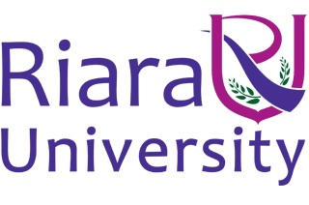

Riara School of International Relations & Diplomacy

Nurturing innovators

SEPTEMBER – DECEMBER 2016 TRIMESTER

EXAMINATIONS FOR DIPLOMA IN INTERNATIONAL RELATIONS & DIPLOMACY

DAY PROGRAMME

RDI 052: INTRODUCTION TO DIPLOMACY

DATE: DECEMBER 2016 TIME: 2 HOURS

INSTRUCTIONS
- Answer question ONE and any other TWO
- Write your answers in paragraph form unless stated otherwise
- Arrange your work neatly and indicate the questions answered in the
Examination booklet

QUESTION 1 (COMPULSORY 30 MARKS)
- Define diplomacy and explain its essence? (4 Marks)
- Distinguish between hard power diplomacy and soft power diplomacy (4 Marks)
- Using an example, explain ‘track one’ diplomacy. (2 Marks)
- Identify any four international institutions that provide a platform for conference diplomacy.
(2 Marks)
- State two benefits of resident embassies (4 Marks)
- Discuss any three policy areas of one Foreign Policy case study of your choice. (6 Marks)
- Discuss any two shortcomings of summit diplomacy (4 Marks)
- Identify four key functions of bilateral diplomacy (4 Marks)
QUESTION 2 (20 MARKS)
With relevant examples, compare and contrast open and secret diplomacy. (20 Marks)

QUESTION 3 (20 MARKS)
a) What is the relevance of international organizations in diplomacy? (10 Marks)
b) Identify and comment on FIVE functions of diplomatic missions (10 Marks)

QUESTION 4 (20 MARKS)
a) Explain FIVE functions of the Ministry of Foreign Affairs as an organ of diplomacy. (10 Marks)
b) Describe how bilateral and multilateral diplomacy complement each other. (10 Marks)

QUESTION 5 (20 MARKS)
Describe the evolution of diplomacy, identifying key landmark events. (20 Marks)

*****END****

