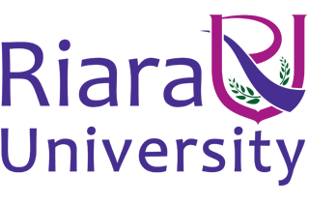

Riara School of International Relations & Diplomacy
Nurturing innovators

SEPTEMBER – DECEMBER 2016 TRIMESTER
EXAMINATIONS FOR BACHELOR OF ARTS IN INTERNATIONAL RELATIONS & DIPLOMACY

DAY/EVENING PROGRAMME

RIR 1101: INTRODUCTION TO INTERNATIONAL RELATIONS
DATE: DECEMBER 2016 TIME: 2 HOURS

INSTRUCTIONS
- Answer question ONE and any other TWO
- Write your answers in paragraph form unless stated otherwise
- Arrange your work neatly and indicate the questions answered in the
Examination booklet
SECTION A: Answer all questions (30 Marks)
QUESTION ONE
- Explain the following terms in international relations: (20 Marks)
  - Theory
  - Power
  - Just War
  - Balance of power
  - Sovereignty
  - Anarchy
  - Imperialism
  - Zero-sum game
  - Cold war
  - Bourgeoisie
- Compare the realist and liberalist assumptions on power and anarchy. (10 Marks)

SECTION B: Answer two questions (40 Marks) Each question is 20 Marks
QUESTION TWO
- Discuss the relationship between terrorism and globalization. (10 Marks)
- Using relevant examples, discuss the successes and failures of collective security. (10 Marks)

QUESTION THREE
Explain the challenges of globalization to the traditional theories of International Relations. (20 Marks)
QUESTION FOUR
- Compare and contrast principles of Marxism and realism. (10 Marks)
- Describe the evolution of the Bretton Woods system and the purpose of its key institutions. (10 Marks)

QUESTION FIVE
- Examine the impact of foreign policy and diplomacy on economic growth. (10 Marks)
- “Human rights are Western and not universal.” Comment. (10 Marks)

*****END****

