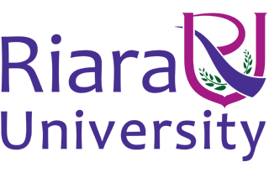

Riara School of International Relations & Diplomacy
Nurturing innovators

SEPTEMBER – DECEMBER 2016 TRIMESTER
EXAMINATIONS FOR BACHELOR OF ARTS IN INTERNATIONAL RELATIONS & DIPLOMACY

DAY/EVENING PROGRAMME

RIR 1202: INTRODUCTION TO POLITICAL SCIENCE
DATE: DECEMBER 2016 TIME: 2 HOURS

INSTRUCTIONS
- Answer question ONE and any other TWO
- Write your answers in paragraph form unless stated otherwise
- Arrange your work neatly and indicate the questions answered in the
Examination booklet

Section A: Compulsory (30 Marks)
QUESTION ONE
- Politics is not only an art of government but also a ‘master science’ (Aristotle 1). Discuss this assertion. (20 Marks)
- Explain the main characteristics of a government. (10 Marks)

Section B: Answer any two questions
QUESTION TWO
Using examples where appropriate, discuss the three main objectives of a state in international relations. (20 Marks)
QUESTION THREE
Parliamentary system of government differs from a presidential one. Using four key considerations, discuss this observation. (20 Marks)

QUESTION FOUR
Using classifications of states according to Aristotle, discuss the merits and demerits of six types of states. (20 Marks)

QUESTION FIVE
Define multiparty system and discuss its merits and demerits (20 Marks)

*****END****

