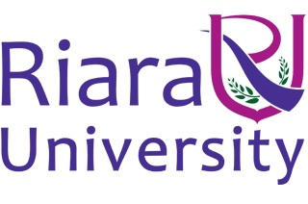

Riara School of International Relations & Diplomacy
Nurturing innovators

SEPTEMBER – DECEMBER 2016 TRIMESTER
EXAMINATIONS FOR BACHELOR OF ARTS IN INTERNATIONAL RELATIONS & DIPLOMACY

DAY/EVENING PROGRAMME

RIR 1105: INTODUCTION TO INTERNATIONAL LAW

DATE: DECEMBER 2016 TIME: 2 HOURS

INSTRUCTIONS
- Answer Question ONE (COMPULSORY) and Any other TWO
- Answers that demonstrate independence of thought rather than cramming will earn more marks
- Write your answers in paragraph form unless stated otherwise

SECTION 1: COMPULSORY (30 MARKS)

QUESTION ONE
1. (a) Define International Law . (2 Marks)

(b) Explain the importance International Law in the study and practice of the following disciplines.
(i) International Relations (2 Marks)
(ii) Diplomacy (2 Marks)

(c) Explain the following terms and principles as used in International Law;
(i) Equidistance principle (3 Marks)
(ii) jus cogens (3 Marks)
(iii) pacta sunt servanda (3 Marks)
(iv) utti possidetis (3 Marks)

(d) Define Law of the Sea and explain why is UNCLOS (1982) referred to as the “Constitution” of the seas and oceans? . (4 Marks)

(e) Name any FOUR demarcations/zones of the seas and oceans according to UNCLOS (1982) stating the rights of the coastal state in each demarcation/zone.
(8 Marks)

SECTION B-ANSWER ANY TWO QUESTIONS

QUESTION TWO (20 MARKS)
Explain the process of Treaty Making in International Law as outlined in the Vienna Convention on the Law of Treaties (VCLT). (20 Marks)

QUESTION THREE (20 MARKS)
Identify and comment on the subjects of International Law. (20 Marks)

QUESTION FOUR (20 MARKS)
Using relevant examples, discuss the various sources of International Law according to article 38 of the International Court of Justice (ICJ) Statute. (20 Marks)

QUESTION FIVE (20 MARKS)
Highlighting the central view espoused by each, discuss any FOUR theories on which the study of International Law is grounded (20 Marks)

***END***

