
UNIVERSITY EXAMINATIONS
EXAMINATION FOR JANUARY / APRIL 2017/2018 FOR BACHELOR OF SCIENCE IN COMPUTER SCIENCE

RCS 101: - DIGITAL LOGIC.
DATE: / /2018 TIME: 2 HOURS

GENERAL INSTRUCTIONS:
Students are NOT permitted to write on the examination paper during reading time.
This is a closed book examination. Text book/Reference books/notes are not permitted.

SPECIAL INSTRUCTIONS:
This examination paper consists Questions in Section A followed by section B.
Answer Question 1 and any Other Two questions.
QUESTIONS in ALL Sections should be answered in answer booklet(s).

- PLEASE start the answer to EACH question on a NEW PAGE.
- Keep your phone(s) switched off at the front of the examination room and NOT on your person.
- Keep ALL bags and caps at the front of the examination room and DO NOT refer to ANY unauthorized material before or during the course of the examination.
- ALWAYS show your working.
- Marks indicated in parenthesis i.e. ( ) will be awarded for clear and logical answers.
- Write your REGISTRATION NO. Clearly on the answer booklet(s).
- For the Questions, write the number of the question on the answer booklet(s) in the order you answered them.
- DO NOT use your PHONE as a CALCULATOR.
- YOU are ONLY ALLOWED to leave the exam room 30minutes to the end of the Exam.
- Calculator will be required.

SECTION A (COMPULSORY)

Question (1) - (30Marks)
- Differentiate between analog and digital signals. (2 Marks)

- Define the following terms? (8 Marks)
- Bit.
- Byte.
- A.D.C.
- D.A.C.
- Encoder.
- Decoder.
- Multiplexer.
- De-multiplexer.

- Differentiate between the Binary and Gray Code number systems. (2 Marks)

- Convert the following numbers into the stated format. (8 Marks)

- 17.25₁₀ -into binary number format.
- 10011001.100101₂ -into decimal number format.
- A0B1CF₁₆ -into octal number format.
- 3467₈ -into decimal number format.

- Draw the circuit diagram to represent the Boolean function below. (6 Marks)
$Y_{o} =\left(A⨁B\right)C+ \overline{B}( A+\overline{C} )+\overline{A}B\overline{C}$

- Derive the Boolean function equivalent to the logic circuit below. (4 Marks)
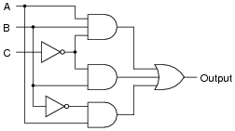

SECTION B (Answer Any Two Questions)

Question (2) - (20Marks)

- State and describe in details FIVE microchips integration scales level used in digital microchips manufacturing/fabrication. (5 Marks)

- Describe FOUR number systems used in digital logics and digital computer systems. (4 Marks)

- With respect to digital logic gates,
- Name TWO universal logic gates. (2 Marks)

- Explain why and how universal logic gates are used. (2 Marks)

- Implement an AND gate using any universal logic gates. (2 Marks)

- Considering the circuit logic below, draw a truth table for the input against the output and hence state its equivalent single logic gate. (5 Marks)

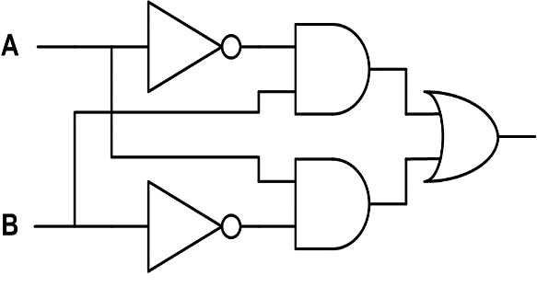

Question (3) - (20Marks)

- The figure below shows a combinational logical circuit, derive the output Y₀ and then simplify the Boolean function, to its simplest form. (10 Marks)

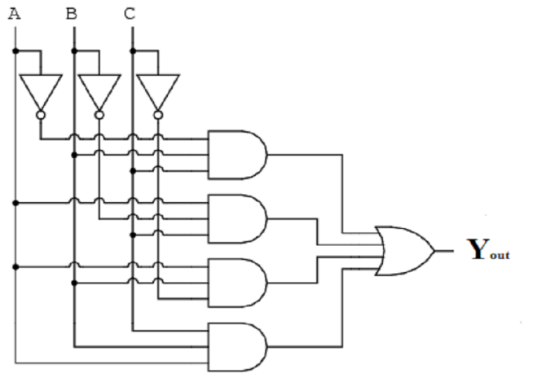

- Solve the following conversions. (Show working). (10 Marks)

- 10101010₂ -into hexadecimal format.
- A0B1C2D3₁₆ -into octal number format.
- 218₁₀ -into binary number format.
- 10101101₂ -into Decimal number format.
- 1234567₈ -into hexadecimal format.

Question (4) - (20Marks)
- With respect to digital signal propagation in digital systems, describe the following terms. (5 Marks)

- Fan-in.
- Fan-out.
- Fall time.
- Rise-time.
- Propagation Delay.

- Design a three bit Binary to Gray code converter from the basic designing procedures and implement the logical circuit. (5 Marks)

- Perform the following calculations. (Show working). (10 Marks)

- 4436₈ - 11001101101₂ - Express result in Oct.
- 25698₁₀ + 7436₈ - Express result in Hex.
- 86FC0₁₆ - 45712₈ - Express result in Bin.
- FF₁₆ x 10₁₀ - Express result in Dec.
- 6FBA₁₆ + E6B7₁₆ - Express result in Hex.

Question (5) - (20Marks)
- With respect to logic gates used in digital electronics, draw basic gates used and indicate their Boolean functions as well as truth tables. (7 Marks)

- Using truth tables prove that the follow relation, is true. (5 Marks)

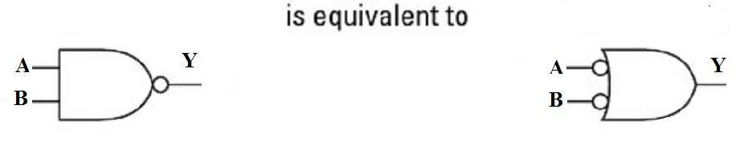

- Design a full adder and implement the circuit. (8 Marks)

