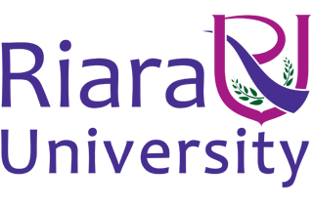

RIARA LAW SCHOOL

UNIVERSITY EXAMINATION FOR BACHELOR OF LAWS (LLB) DEGREE

AND

PRE-KENYA SCHOOL OF LAW CORE COURSES COMPLIANCE PROGRAM

SEPTEMBER- DECEMBER 2018

RLB 202: LEGAL RESEARCH AND WRITING 2

INSTRUCTOR: Dr. VICTOR LANDO

INSTRUCTIONS
- This is the final examination in Legal Research and Writing 2. You will earn 70% of your final grade from this final examination and 30% from Continuous Assessment Assignments.
- This examination has ONE question
- This examination has 2 pages, including this one.
- You must hand in your script when time is called.
- Please sign the roll sheet when you turn in your answer sheet. If you fail to sign the roll sheet, we shall have no way of establishing that you sat for this examination and your marks will not be reported.
- This examination is governed by Riara University Academic Honesty Regulations. Students who violate those regulations will be penalized. Students have an obligation to report to the invigilator any incidences of academic dishonesty compromising the integrity of this examination.

Question One (70 marks)

You are required to hand in a well researched, well written 15-page article on any field of law of your interest. The article must be your original work, which has not been submitted for publication or assessment at any institution. You must reference you article in line with the OSCOLA guidelines.

